**Morris twp Volunteer Fire Department**

1st Annual Clay Shoot

Sunday,

May 19th, 2013

Split Rail Sporting Clays

663 Templeton Run rd

Claysville, PA 15323

(724) 663-RAIL

Email: [splitrailsportingclay@verizon.net](mailto:splitrailsportingclay@verizon.net)

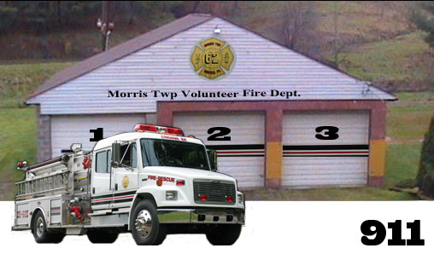

PROCEEDS TO BENEFIT

**Important information**

• All Shooters must provide their own equipment

• Carts $20 per seat (no singles on carts) or if you have your own quad runner/golf cart you are welcome to use it

• Everyone on course must wear eye and ear protection at all times

• Teams must shoot in groups of **FOUR**. Single shooters will be assigned to a team on the event day

• Please include registration form with payment

• Payments are non-refundable

***Directions:***

East/West- I-70 Exit 6, E on rt. 40 to 231 S, follow to E. Finley twp. Bldg, turn right onto Templeton Run rd., turn right- we are on the right.

South- I-79 to Waynesburg Exit, to 18 N, follow to E Finley twp bldg on right, turn left on Templeton Run rd, we are on the right.

**ThanK YOU IN ADAVANCE FOR YOUR SUPPORT!**

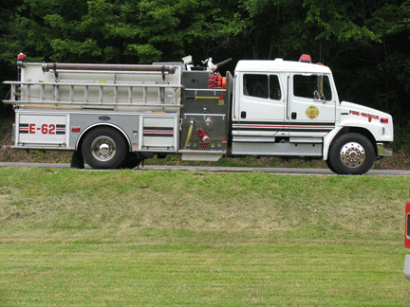

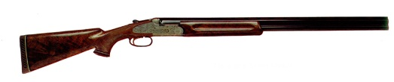

The New Home of the Shooting Enthusiast

### REGISTRATION FORM

Shooter #1 ________________________

Address___________________________________________________________

Phone:________________________

Email:________________________

Requested Group:

2)__________________________

3)__________________________

4)__________________________

*Please return registration form with payment by **May 05, 2013**\*

Please check below

PLEASE MAKE CHECK Payable to: SPLIT RAIL SPORTING CLAYS

_____Course + Meal $45 (per person)

_____Reserve a Golf Cart $20 *per seat, no singles on carts*

*Ex. 2 person cart $40*

*4 person cart $80*

PLEASE MAKE CHECK Payable to: Morris twp Volunteer Fire Department

____Event minimum donation $15 (per person)

(Reference “clay shoot”)

Total amount enclosed $______

Please mail payments and registration form to:

Split Rail Sporting Clays

663 Templeton Run Rd

724-663-7245

Claysville, PA 15323

*Important Information on back*

**EVENT FEES**

**Event fee**: $60 (per person)

*includes course + meal $45

*donation $15

**\*plaques for 1st & 2nd place team\***

**Golf Cart fee**: $20 *per seat*  *Ex. 2 person cart $40*

*4 person cart $80*

(No singles on carts) (Must be reserved in advance)

**Sign Sponsorship**

$50.00

*Must receive payment and name or company information to appear on sign by **5-05-2013**\*

Please make check out to: Morris twp. Volunteer Fire Department

Mail sign sponsorship payment to:

Morris twp. Volunteer Fire Department

P.O. Box 98

Nineveh, PA 15353

Your sign sponsorship will be displayed on the course on day of event

### Event schedule

**Registration**

11:30 am– 12:30 pm

**Shotgun Start**

1:00 Pm

BBQ Ribs & Chicken Meal following shoot

Five Stand & Long Bird Competition (payable at event)

**\*plaques for   
1st & 2nd place team*!!!**

